**C CHAPTER1 EXERCISE:**

1. Write a C program to print 'Hello' on screen and then print your name on a separate line.

#include<stdio.h>

int main()

{

printf("Hello\n");

printf("Kishore Kumar");

return 0;

}

Output:

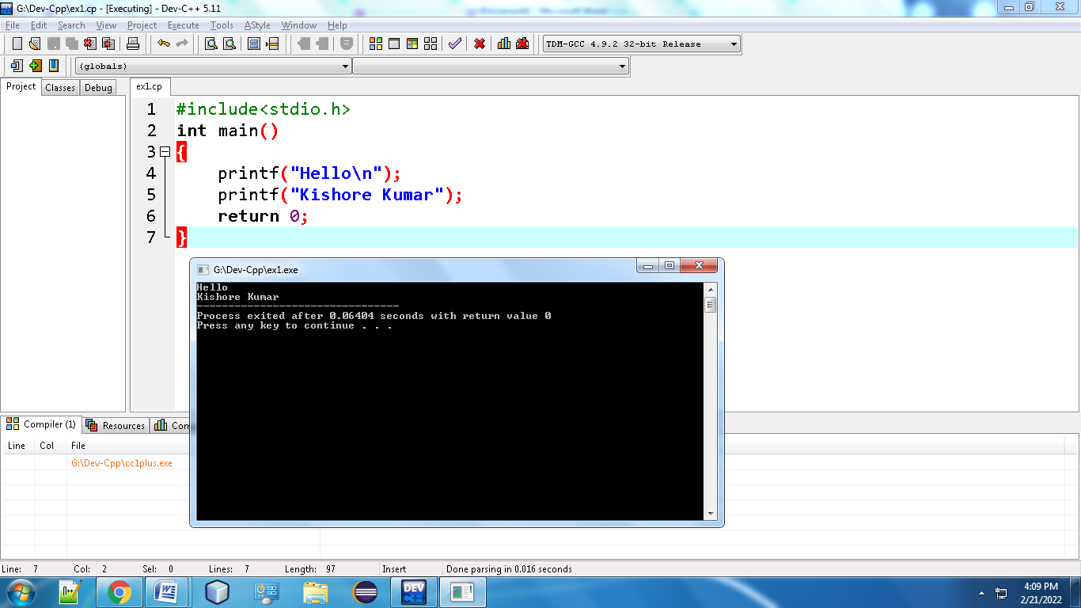

1. Write a C program to print the sum of two numbers.

#include<stdio.h>

int main()

{

int a=80;

int b=8;

printf("The Sum of Two Numbers is:%d",(a+b));

return 0;

}

Output:

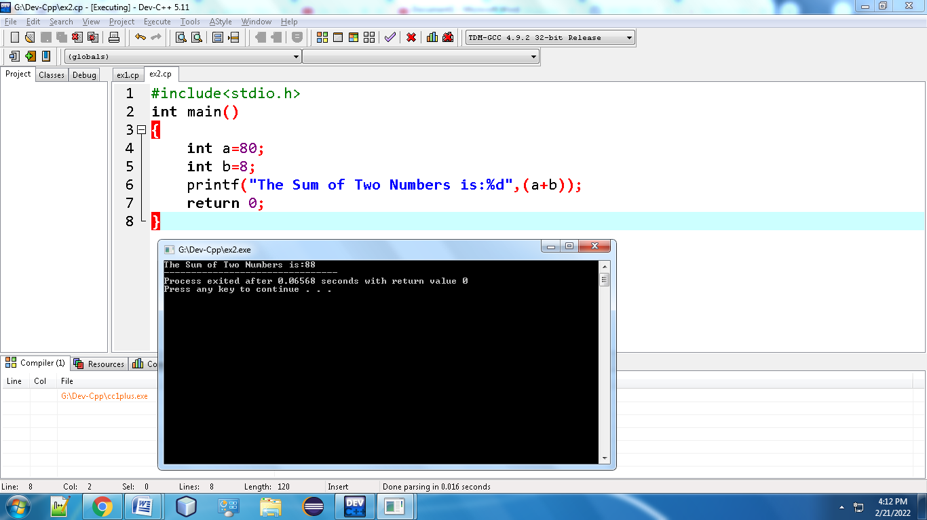

1. Write a C program to print the result of the following operations

1)Addition

2)Subtraction

3)Multiplication

#include<stdio.h>

int main()

{

int a=21;

int b=7;

printf("The Addition of Two Numbers is:%d\n",(a+b));

printf("The Subtraction of Two Numbers is:%d\n",(a-b));

printf("The Multiplication of Two Numbers is:%d",(a*b));

return 0;

}

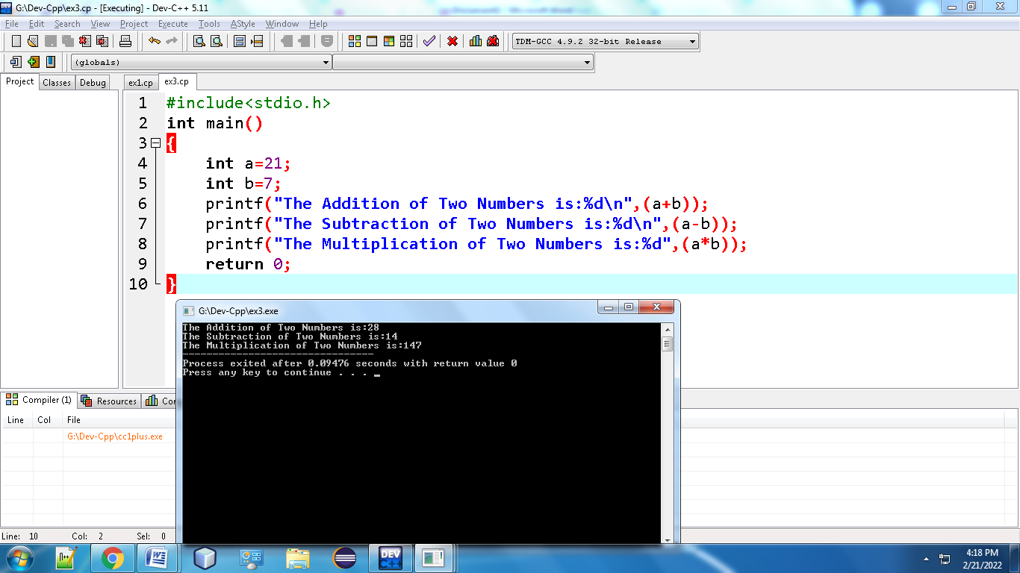

**4.** Write a C program that takes two numbers as input and display the product of two numbers.

#include<stdio.h>

int main()

{

int p,q,r;

printf("Enter The Value of P is:");

scanf("%d",&p);

printf("Enter The Value of Q is:");

scanf("%d",&q);

r=p*q;

printf("The Product of Two Number is:%d",r);

return 0;

}

Output:

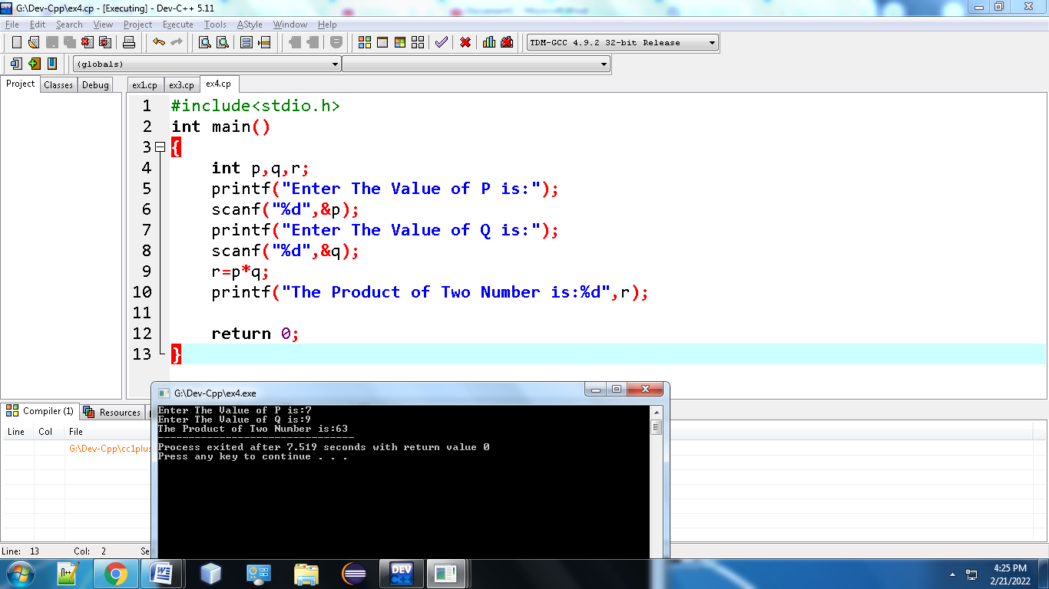

5.Write a C program to print the sum (addition), multiply, subtract, divide and remainder of two numbers

#include<stdio.h>

int main()

{

int x,y,z;

printf("Enter The Value of x is:");

scanf("%d",&x);

printf("Enter The Value of y is:");

scanf("%d",&y);

z=x+y;

printf("The Result of Addition is:%d\n",z);

z=x-y;

printf("The Result of Subtraction is:%d\n",z);

z=x*y;

printf("The Result of Multiplication is:%d\n",z);

z=x/y;

printf("The Result of Division is:%d\n",z);

z=x%y;

printf("The Result of Modulus is:%d",z);

return 0;

}

Output:

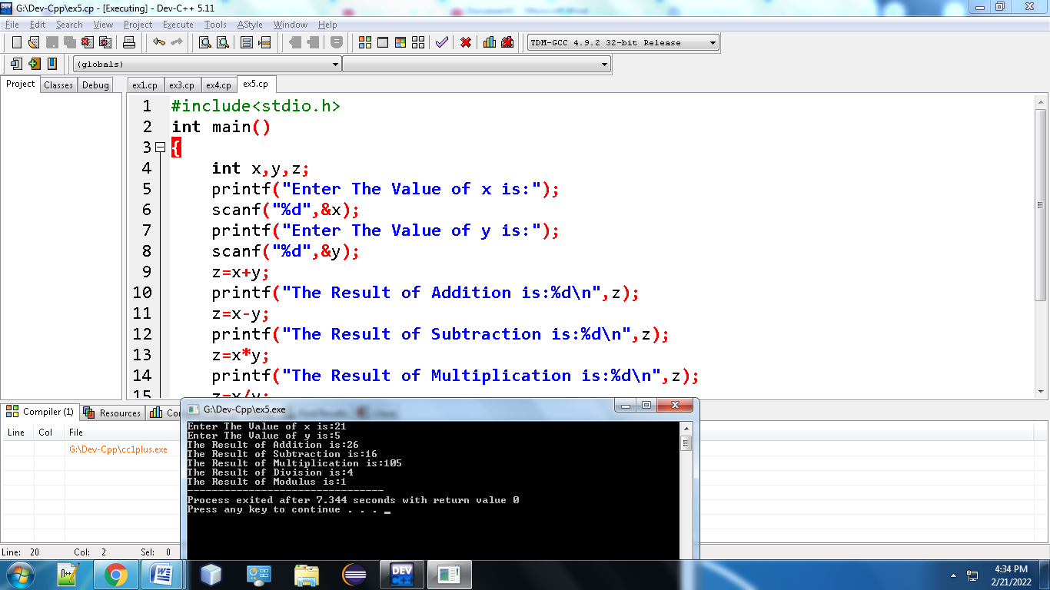

6.Write a C program that takes a number as input and prints its multiplication table upto 10.

#include <stdio.h>

int main() {

int n, i;

printf("Enter an integer: ");

scanf("%d", &n);

for (i = 1; i <= 10; ++i) {

printf("%d * %d = %d \n", n, i, n * i);

}

return 0;

}

Ouput:

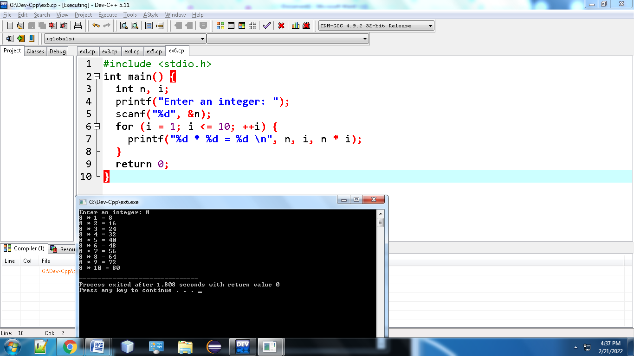

9.Write a C program to print the area and perimeter of a circle.

#include<stdio.h>

int main()

{

float r, Area, Perimeter;

printf("Enter the radius of circle:");

scanf("%f",&r);

Area = 3.14*r*r;

Perimeter=2*3.14*r;

printf("the area of the circle is %f\n",Area);

printf("the perimeter of the circle is %f\n",Perimeter);

return 0;

}

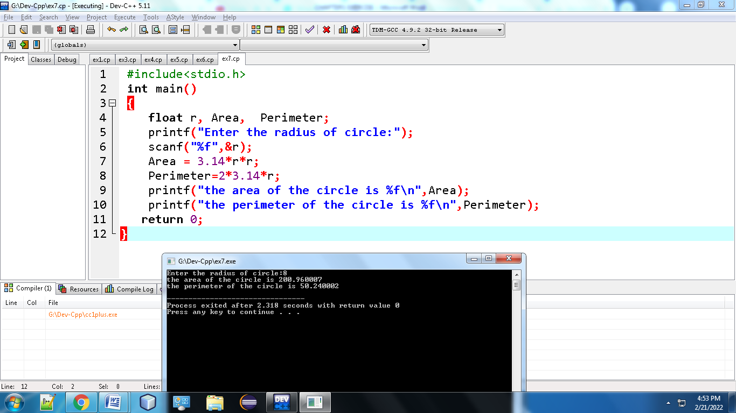

**10.** Write a C program that takes three numbers as input to calculate and print the average of the numbers.

#include<stdio.h>

int main()

{

int s1,s2,s3;

float sum, avg;

printf("Enter The Value of s1 is:");

scanf("%d",&s1);

printf("Enter The Value of s2 is:");

scanf("%d",&s2);

printf("Enter The Value of s3 is:");

scanf("%d",&s3);

sum=s1+s2+s3;

printf("The Sum of Three Numbers is:%f\n",sum);

avg=sum/3;

printf("The Average of Three Numbers is:%f",avg);

return 0;

}

Output:

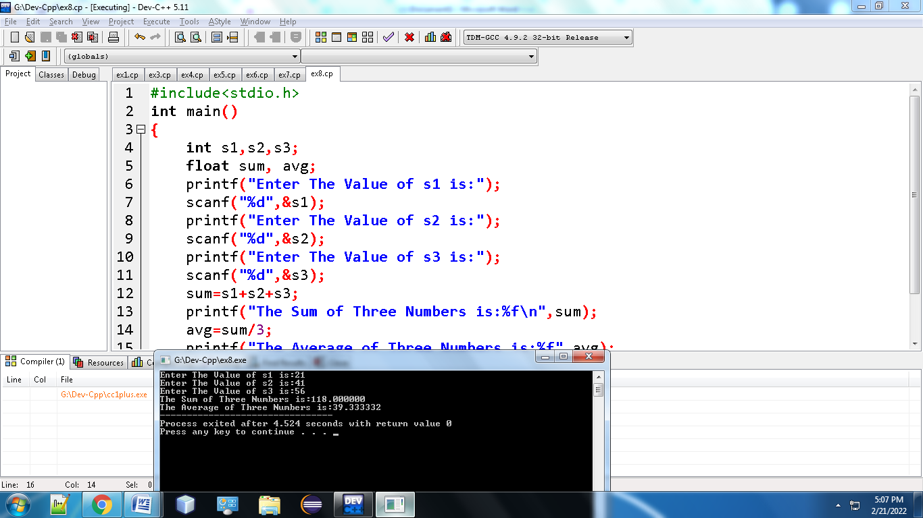

**11.** Write a C program to swap two variables.

#include<stdio.h>

int main() {

int first, second, temp;

printf("Enter first number: ");

scanf("%d", &first);

printf("Enter second number: ");

scanf("%d", &second);

temp = first;

first = second;

second = temp;

printf("\nAfter swapping, first number = %d\n", first);

printf("After swapping, second number = %d", second);

return 0;

}

Output:

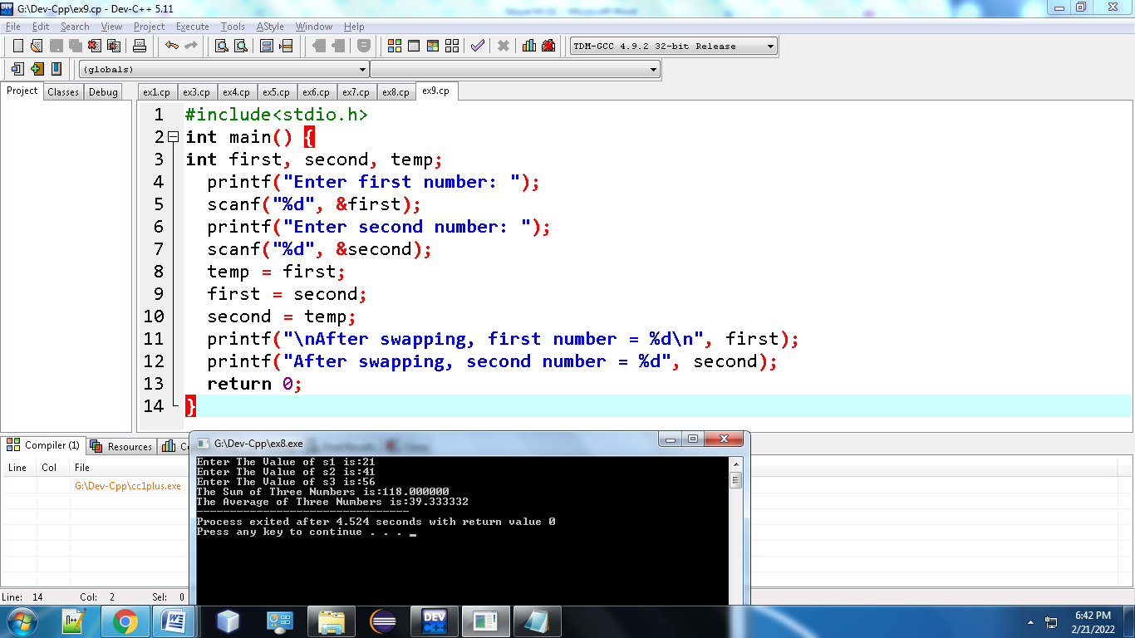

**12.** Write a C program to convert a decimal number to binary number.

#include <stdio.h>

int main()

{

int a[10], number, i, j;

printf("\n Please Enter the Number You want to Convert : ");

scanf("%d", &number);

for(i = 0; number > 0; i++)

{

a[i] = number % 2;

number = number / 2;

}

printf("\n Binary Number of a Given Number = ");

for(j = i - 1; j >= 0; j--) {

printf(" %d ", a[j]);

}

printf("\n");

return 0;

}

Output:

